# Darknet 53

## What is Darknet-53?

Darknet-53 plays an important role in the performance of the YOLOv3 object detection system. Darknet-53 is an upgrade from its predecessors, Darknet-19 and Darknet-21, used in earlier YOLO versions. The Darkent-53 has 53 convolutional layers, which makes it deeper and more powerful. The depth increase helps the network capture more complex features, improving its detection capabilities. It was introduced by Joseph Redmon and Ali Farhadi in 2018 in their research paper “YOLOv3: An incremental improvement”, which showcases significant advancements in object detection capabilities. This network is designed to offer a balance between speed and accuracy, making it suitable for real-object detection applications.

## Darknet-53 Architecture

It is an evolution from its predecessors, Darknet-19 and Darknet-21, which were used in earlier YOLO versions. This architecture follows a modular design, where each module consists of a set of convolutional layers followed by shortcut connections. These shortcut connections are inspired by ResNet architecture, which helps in mitigating the vanishing gradient problem, enabling the training of much deeper networks.

Here are the components of Darknet-53:

1. Convolutional Layers: The Darknet-53 consists of 53 convolutional layers with various kernel sizes, mainly using 3x3 and 1x1 filters. These layers are designed to extract hierarchical features from the input images.
2. Batch Normalization: Each convolutional layer is followed by batch normalization, which helps in stabilizing the training process and accelerates convergence.
3. Leaky ReLU Activation: Leaky ReLU is used as the activation function, which helps in maintaining non-linearity while addressing the dying ReLU problem.
4. Shortcut Connections: Just like ResNet, Darknet-53 has shortcut connections that allow gradients to flow more effectively through the network during training. It provides results in better training of deeper layers.
5. Downsampling Layers: The network includes downsampling layers that reduce the spatial dimensions of the feature maps while increasing the depth. This hierarchical reduction is crucial for capturing features at multiple scales.

## Detailed layer configuration

The darknet-53 architecture can be visualized as a series of stages, each containing several residual blocks. The image below summarizes the configuration of Darknet-53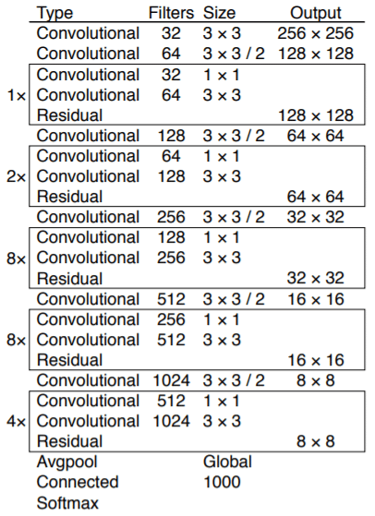

## Performance

Darknet-53 is designed to strike a balance between speed and accuracy that makes it very useful in real-life applications. In the research paper, the researchers compare their Darknet-53 with other popular architectures like ResNet-152, demonstrating that the Darknet-53 offers a better trade-off between speed and accuracy. Darknet-53 achieves a higher mean Average Precision (mAP) while maintaining a higher inference speed, crucial for real-time detection tasks.

## Implementation in YOLOv3

The Darknet-53 is the backbone network of YOLOv3, meaning it is responsible for extracting features from input images that are subsequently used by the YOLOv3 detection layers. The deep and rich features extracted by Darknet-53 enable YOLOv3 to detect objects at different scales effectively.

YOLOv3 introduces a multi-scale detection approach, in which detections are made at three different scales. To achieve this, we add detection layers at different points in the network, leveraging the hierarchical feature maps produced by Darknet-53. This multi-scale approach significantly improves the detection of small objects, which was a limitation in earlier YOLO versions.

## Advantages of Darknet-53

1. Efficiency: Darknet-53 achieves a balance between speed and accuracy, which makes it suitable for real-life problems and applications.
2. Deep Architecture: It has 53 layers of convolutional layers that extract detailed features from images, enhancing the detection performance.
3. Residual Connections: The incorporation of residual blocks helps in training the deep network effectively without suffering from the vanishing gradient problem.
4. Flexibility: Darknet-53 can be used as a standalone feature extractor or as a backbone for object detection models like YOLOv3.

## Applications of Darknet-53

Darknet-53, primarily used in YOLOv3, is widely adopted in various real-time object detection tasks, including:

1. Surveillance Systems: Real-time monitoring and detection of objects in security footage.
2. Autonomous vehicles: Object detection for navigation and obstacle avoidance.
3. Robotics: Enhancing the vision capabilities of robots for tasks like object manipulation and navigation.
4. Healthcare: Assisting in medical image analysis and diagnosis by detecting abnormalities.

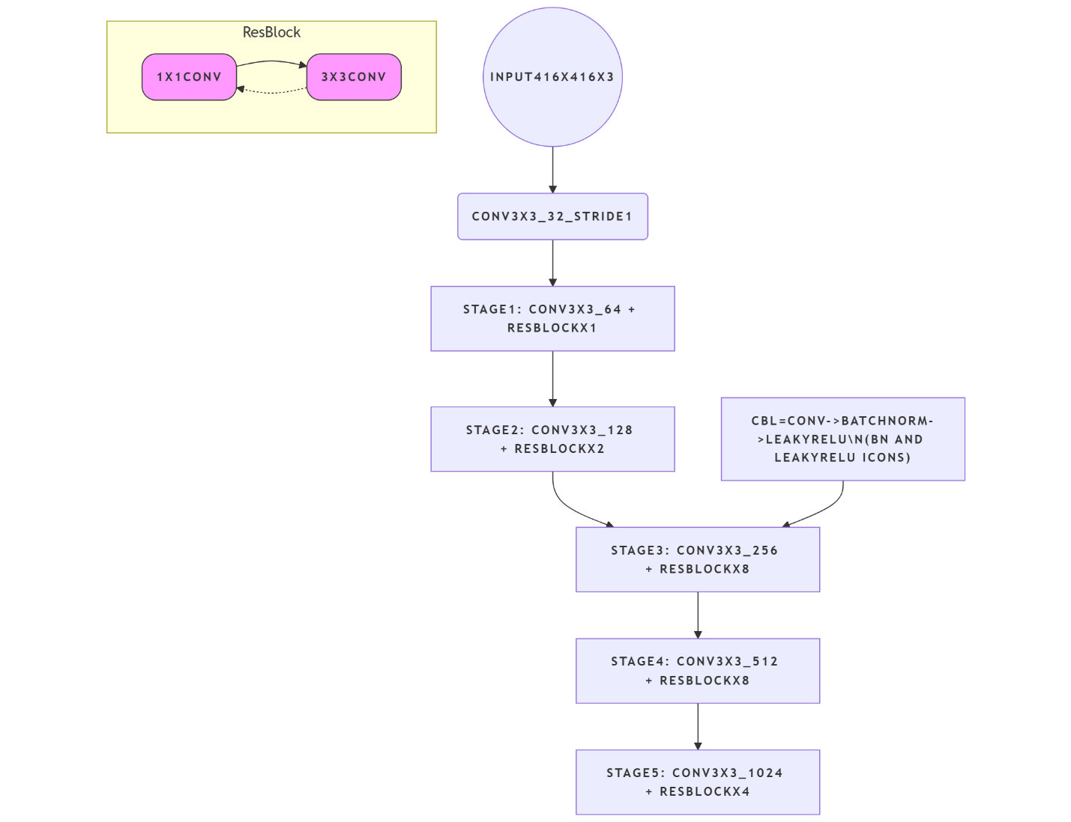

Darknet53 Flowchart

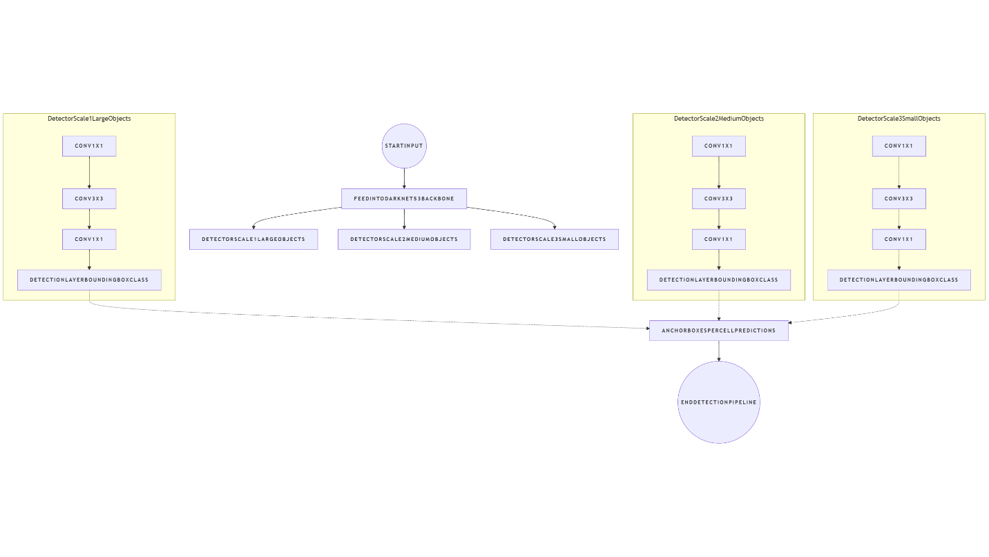

YOLOv3 FlowChart

## Conclusion

Darknet-53 is a significant advancement in convolutional neural network architectures, providing a robust and efficient backbone for object detection systems. Its deep structure, combined with residual connections, enables high-performance real-time object detection, making it a valuable tool in various fields requiring quick and accurate object recognition.

# YOLOv5

## Overview

YOLOv5 represents an advancement in object detection methodologies. YOLOv5 integrates the anchor-free, objectness-free split head. This adaptation refines the model’s architecture, leading to an improved accuracy-speed tradeoff in object detection tasks. Provided the empirical results and their derived features, YOLOv5 provides an efficient alternative for those seeking robust solutions in both research and practical applications.

## YOLOv5 architecture

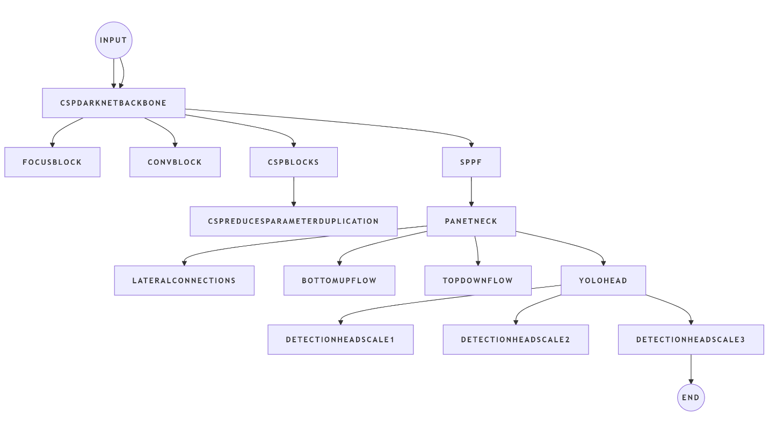

YOLOv5 FlowChart

The YOLOv5 architecture is a single-stage object detection model known for its balance of speed and accuracy. It has three main parts:

### Backbone (CSPDarknet53):

This component is responsible for feature extraction from the input image.

It is based on the Darknet architecture but incorporates Cross-Stage Partial (CSP) connections. CSP connections improve learning efficiency and reduce the model’s computational cost by optimizing the gradient flow.

The backbone typically includes various convolutional layers, batch normalization, and activation functions (like SiLU in later versions).

A Spatial Pyramid Pooling Fast (SPPF) block is often included at the end of the backbone to increase the receptive field and handle objects of different scales efficiently.

### Neck (PANet):

The neck connects the backbone and the head, facilitating the aggregation of features from different scales.

It utilizes a Path Aggregation Network (PANet) structure, which includes both top-down and bottom-up pathways.

The top-down pathway upsamples features from deeper layers and concatenates them with features from shallower layers, providing richer semantic information.

The bottom-up pathway downsamples features and concatenates them with features from the top-down pathway, enhancing localization information.

Similar to the backbone, CSP blocks are often integrated into the neck pathways in YOLOv5 to further improve efficiency.

### Head (YOLO Layer):

This is the final component responsible for predicting the bounding boxes, objectness scores, and class probabilities.

It uses features aggregated by the neck to make predictions for objects at different scales, typically using anchor boxes.

The head consists of convolutional layers that output the final detection results.

YOLOv5 models come in various sizes (e.g., n, s, m, l, x), which represent different scales of the network, offering a trade-off between speed and accuracy to suit diverse application requirements.

# YOLOv8

## Overview

It is released on January 10th, 2023, and it offers cutting-edge performance in terms of accuracy and speed. It is built upon previous YOLO versions and makes advancements on itself. YOLOv8 introduces new features and optimizations that make it an ideal choice for various object detection tasks in a wide range of applications.

## Key features of YOLOv8 Architecture Overview

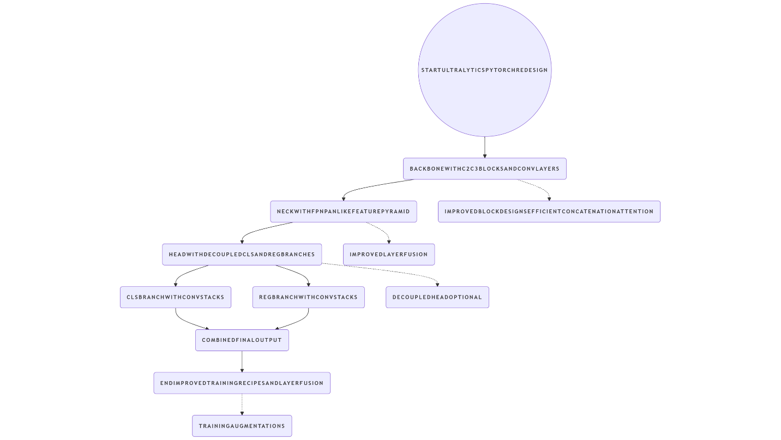

YOLOv8 FlowChart

Here are the key features of the YOLOv8 architecture:

### Backbone Network:

YOLOv8 architecture employs a feature-rich backbone network as its foundation. The network serves to extract hierarchical features from the input image, providing a comprehensive representation of the visual information.

YOLOv8 utilizes CSPDarknet53, a modified version of the Darknet architecture, as its backbone. This modification incorporates Cross Stage Partial networks, enhancing the learning capacity and efficiency.

### Neck Architecture:

The architecture includes a novel neck structure, which is responsible for feature fusion. This is crucial for combining multi-scale information and improving the model’s ability to detect objects of varying sizes.

YOLOv8 introduces PANet (Path Aggregation Network), a feature pyramid network that facilitates information flow across different scales. PANet enhances the model’s ability to handle objects with diverse scales more effectively.

### YOLO Head:

YOLOv8 retains the YOLO series’ characteristic feature- the YOLO head. This component generates predictions based on the features extracted by the backbone network and the neck architecture.

The secrets of YOLOv8 metrics, bounding box coordinates, objectness scores, and class probabilities for each anchor box associated with a grid cell. The architecture utilizes anchor boxes to efficiently predict objects of varying shapes and sizes.

### Training Techniques:

YOLOv8 leverages advancements in training strategies to improve convergence speed and model performance. MixUp, a data augmentation technique, is employed to create linear interpolations of images, enhancing the model’s generalization capabilities.

Additionally, YOLOv8 utilizes a cosine annealing scheduler for learning rate adjustments during training, contributing to more stable convergence.

### Model Variants:

YOLOv8 is available in different variants, each designed for specific use cases. YOLOv8-CSP, for instance, focuses on striking a balance between accuracy and speed. YOLOv8x-Mish, another variant, employs the Mish activation function for improved non-linearity, leading a better generalization and performance.

### YOLOv8 Performance:

YOLOv8 has demonstrated remarkable improvements in terms of accuracy and speed compared to its predecessors. With superior real-time object detection capabilities, YOLOv8 has become a popular choice in various applications, including robotics, surveillance, and augmented reality.

# YOLOv11

## Overview

It is the latest version of the YOLO (You Only Look Once) series. The capabilities of the YOLO model in the field of computer vision make it a great asset in many fields, like robotics, autonomous driving, and medical care. YOLOv11 extends improvements on all fronts: improved performance, speed, and a more efficient design, making it one of the most versatile options to meet present-day object detection requirements.

## Architecture of YOLOv11

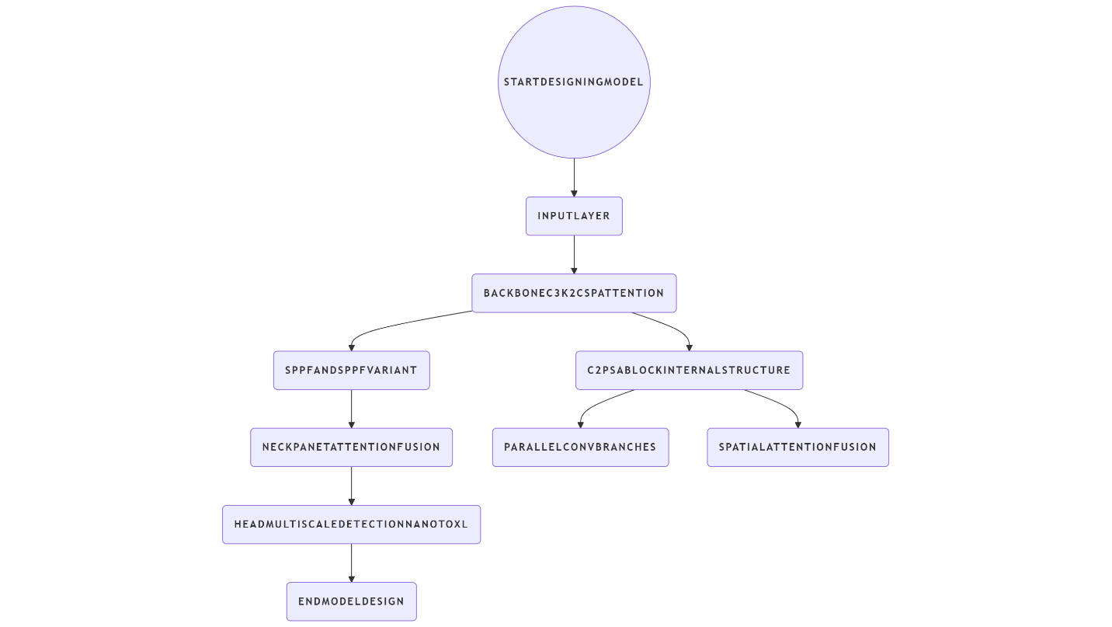

YOLOv11 FlowChart

### Backbone:

The backbone is responsible for feature extraction. YOLOv11 uses a modified CSP (Cross Stage Partial) architecture, which enhances feature learning while reducing computational overhead.

### Neck:

The neck combines features from different layers to improve the model’s ability to detect objects at various scales. YOLOv11 employs a PANet (Path Aggregation Network) for this purpose, improving detection across various object sizes and orientations.

### Head:

The head generates the final output: bounding boxes, class labels, and confidence scores. YOLOv11’s head is optimized for both accuracy and speed, incorporating advanced techniques like anchor-free detection.

### Loss Function:

YOLOv11 uses a combination of classification, localization, and confidence losses, optimized to improve detection accuracy while maintaining fast inference times.